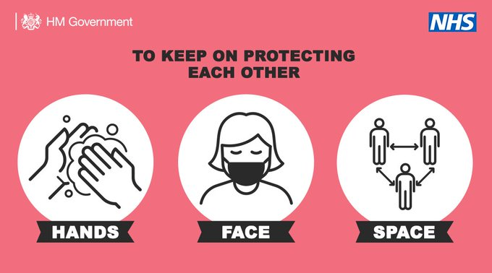

#StayAlert #RuleOfSix #HandsFaceSpace

As with many areas in Europe we are seeing an increase in cases of Covid-19 and for the second consecutive week our district has had a double digit increase in the number of new cases.

I am aware of people trying to access tests without success and would ask people to please only seek a test if you are displaying the Covid-19 symptoms.

On Sunday the Prime Minister announced a new package of measures to support and enforce self-isolation – people will be legally obliged to self-isolate if they test positive or have been asked to self-isolate by NHS Test and Trace – helping to control the spread of the virus, protect the NHS and save lives.
- The best way we can fight this virus is by everyone following the rule of six; wash your hands; cover your face; make space; and self-isolate of you have symptoms or if you have been contacted by NHS Test and Trace.
- From 28 September, people will be required by law to self-isolate – recognising that self-isolation is one of the most powerful tools for controlling the virus. New fines for those breaching the rules will start at £1,000, but could increase to up to £10,000 for repeat offences and for the most egregious breaches.
- But the Government don’t want to see a situation where people don’t feel they are financially able to self-isolate – so the Government are also introducing a new £500 Test and Trace Support payment for those on low incomes who are required by NHS Test and Trace to remain at home.
- Many people are following the rules around self-isolation, but these steps will make sure more do and help ensure the public do not unknowingly spread the virus.

COVID-19 Update Thank you Cllr Anne Parry for sharing this data.

The cumulative cases across the county as of today are now 3025 up from 2867 (an increase of 158 and up by 62 on last week’s figure) with confirmed cases in Stratford on Avon District increasing by 19 to 597 since last week (one less than last week),

Out of the 423 SWFT Hospital Beds there remains NO confirmed cases of COVID-19 at present and NO patients are in the intensive care unit. The cumulative deaths across Stratford District remains at 168 with the deaths in care home remaining at 82 from a cumulative of 1264 ‘all cause deaths’ in the district. The cumulative total of all COVID-19 deaths in Warwickshire is up by one to 600 and over the same period there have been 3772 non COVID-19 related deaths in Warwickshire. Across the county there has been a total of 212 COVID-19 deaths in care homes settings (no increase in the last week) compared to 1264 ‘all cause deaths’ in care homes over the same period.

There are 49% of SWFT hospital beds occupied by Non-COVID-19 patients, 19% beds occupied with suspected COVID-19 patients and a spare capacity of 31% beds.

Have a good week.
Stay Safe and remain alert.
Penny-Anne O’Donnell
Ward Member Ettington Chair Overview and Scrutiny.

