#HandsFaceSpace.

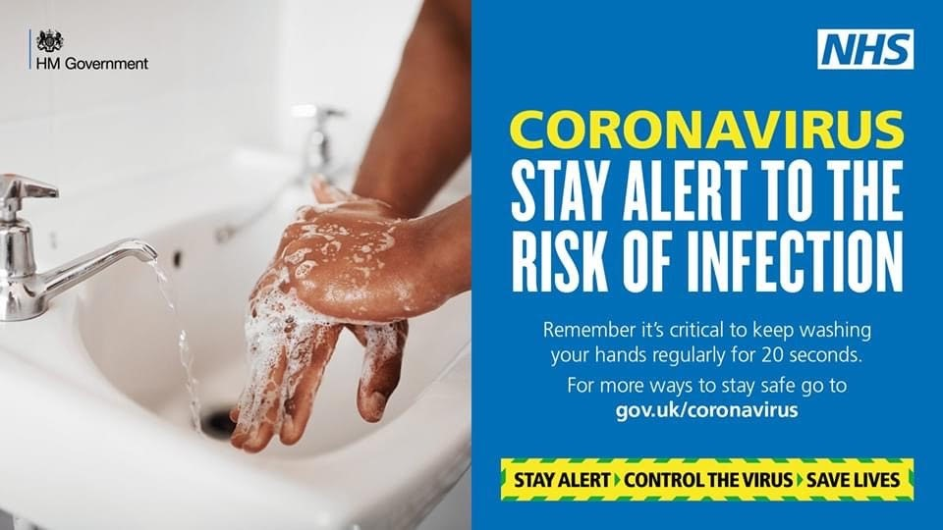

This week is a reminder for us all to remain vigilant as lockdown continues to ease our awareness must remain high. If we consider the strict quarantine rules for people returning from France and the increases seen in countries added to the list of countries to quarantine after visiting, we can see just how vital following the social distancing advice is.
According to the Department for Transport, weekly coronavirus cases are on the rise in Croatia, Austria, Trinidad and Tobago as follows:
- Croatia - 164% increase
- Trinidad and Tobago - 232% increase
- Austria - 93% increase

New enforcement powers
The majority of the public have been diligently following the rules and playing their part in keeping the virus under control, but we cannot be complacent which is why Government are strengthening the enforcement powers available to use against those who continually break the rules.
- That is why in the coming weeks, they are doubling fines to those who repeatedly flout face covering rules to a maximum of £3,200, and will introduce on the spot fines to those who host or facilitate illegal gatherings of more than 30 people.
- 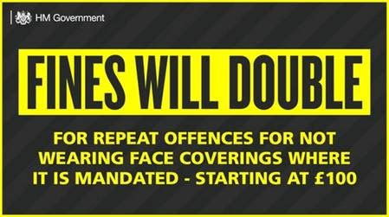

- These measures come as a number of culture, sports, leisure and business sectors across England were permitted to reopen at the weekend:
  - Indoor theatre and music performances can recommence in front of socially distanced audiences, while bowling alleys, skating rinks and casinos will be allowed to open their doors for the first time.
  - The Government are piloting a number of both sporting and business events, in order to ensure both sectors can resume once again as safely as possible in the months ahead.
  - Wedding receptions of up to 30 people will now be permitted.
  - Beauty salons, tattoo studios, spas and barbers in England will be able to offer all close contact services and treatments once more under new guidance. Welcome news for our many entrepreneurs across the ward.
- The plan to reopen society and the economy is conditional, and as Government lifted more lockdown restrictions last weekend, it is vitally important that we continue to follow public health guidance and that people wash their hands, cover their face and make space.
Self Employment Support
Millions of self-employed people whose trade has been hit by coronavirus can now apply for a second support grant from the government.
More than three million people may be eligible for the payment of up to £6,570.
HMRC said it was pleased with the positive start the scheme made when it opened on Monday morning.
By early Monday 39,000 people had successfully made claims, HMRC said.
Visit www.gov.uk to check eligibility.

LOCKDOWN UPDATE Thank you to Cllr Anne Parry for sharing her WCC figures.
The Community is the source of new cases seen within the region and according to Public Health Warwickshire Nuneaton and Bedworth are experiencing a higher occurrence rate than elsewhere within the district. Public Health Warwickshire (PHW) show Nuneaton and Bedworth to have the highest cumulative rate in the West Midlands with a total of 907 cases compared to Stratford on Avon at 536.

Testing and Track & Trace
Testing for Covid-19 has increased over the last few weeks as Warwickshire residents continue to do the right thing by getting themselves tested when they show symptoms.

No matter how mild the symptoms getting tested is vital in our fight against Covid-19.
Within Warwickshire there are a variety of Test settings. You can test at home, drive through or attend a walk in centre. The test is quick and easy, and a crucial tool to help stop the spread of coronavirus in Warwickshire
Locally, Public Health Warwickshire is increasing its capacity to strengthen its response to complex cases and outbreaks with the recruitment of local test and trace officers. They are hopeful that this will also help to quickly identify and contact those who may be at risk following a local outbreak.

Importantly WCC is working very closely with community leads, district and borough councils, health and localities teams to manage any local outbreaks, but Public Health Warwickshire emphasises that they can’t control the virus unless people play their part by getting tested. What may be mild symptoms for one person, could prove fatal for another, so by detecting the virus, self-isolating and stopping the spread, you are potentially saving the lives of the ones you love and those in your community. So, let’s do the right thing for Warwickshire and get tested.

COVID-19 Update
The cumulative cases across the county are now 2643 up from 2622 with confirmed cases in Stratford on Avon District rising to 536 from 532 since the previous week. These cases include data from both Pillar 1 (hospitals and NHS settings) and also Pillar 2 (community). Testing is continuing at Stratford College and the Track and Trace initiative is continuing to work well.

Out of the 424 SWFT Hospital Beds there are currently two inpatient cases of COVID-19 at present and NO patients are in the intensive care unit. The cumulative deaths across Stratford District remains at 168 with the deaths in care homes remaining at 82 in the district. The cumulative total of all COVID-19 deaths in Warwickshire is now 595 (up four over the week) and over the same period there have been 3292 non COVID-19 related deaths in Warwickshire. Across the county there has been a total of 211 COVID-19 deaths in care homes settings (no increase in the last two weeks) compared to 1144 ‘all cause deaths’ in care homes over the same period.

The capacity in hospitals remains excellent and there are 45% of beds occupied by Non-COVID-19 patients, 17% beds occupied with suspected COVID-19 patients and a spare capacity of 38%. Let’s hope that people on the NHS waiting lists for routine procedures don’t have to wait for too long to be seen in view of this capacity.

The messages are clear in that we are definitely in for the long haul and we all must abide by the strict guidelines to put a stop to the virus spreading in our community.

Zoom/TEAMS Surgery.
My next remote surgery is between 10-2 on Tuesday 1st September, please email me at
Penny-Anne.O'Donnell@stratford-dc.gov.uk to book a time.

Keep safe, healthy and socially distanced and continue to support our local businesses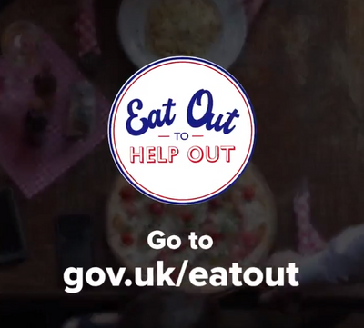

Kind regards
Penny-Anne O’Donnell Ward Member Ettington Chair Audit and Standards.

